
Peter Jendrichovský, PJ Pigeons
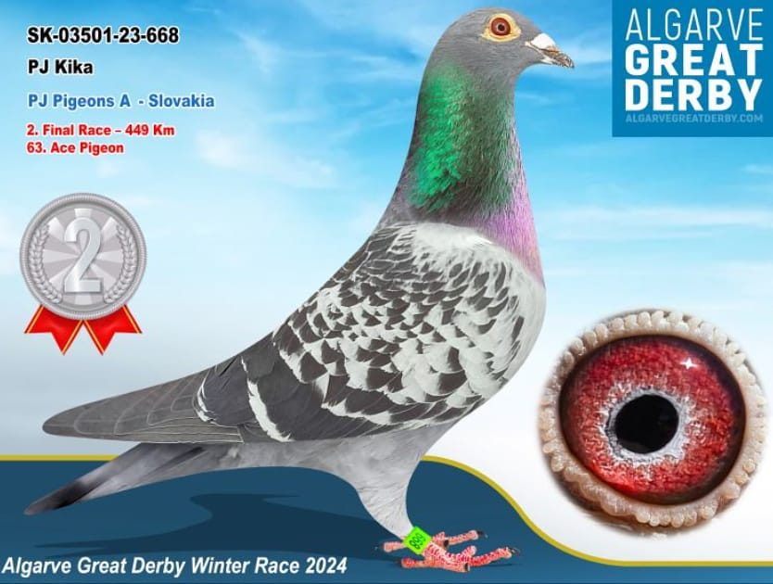
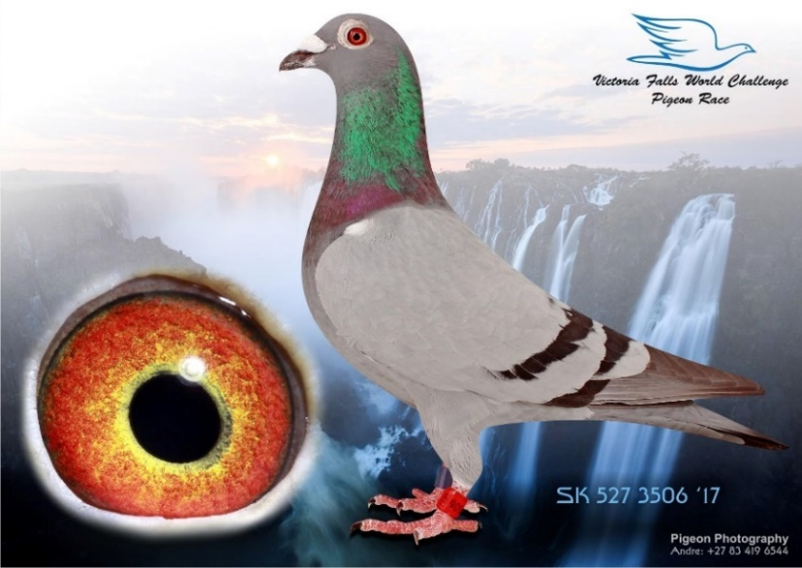
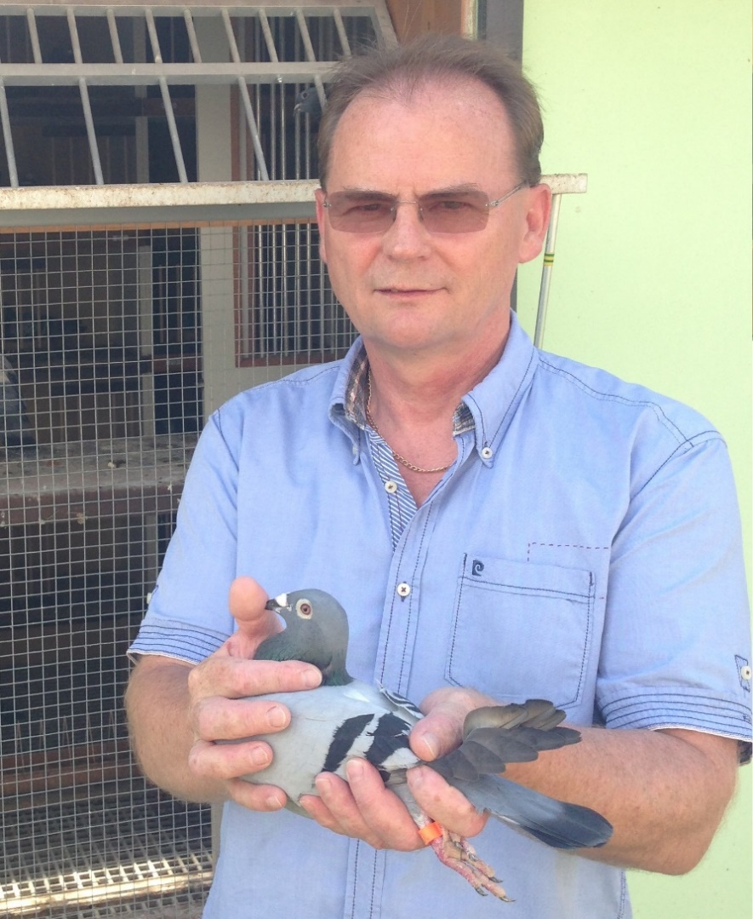
00s
2e Final Algarve Great Derby Winter 2024
“PJ KIKA” ´23-668
1e SemiFinal Derby SUPERSTAR OLR 2024 “PJ LIOPIE“ ’24-843 (315 km)
2e Final Algarve Great Derby Winter 2024 “PJ KIKA“ ’23-668 (449 km)
10e SMALL TEAM Pattaya IPR 2021/22 (8.747 pigeons)
3e Hardest Final Sevilla Winter Race 2020/21 “PJ CINDY” ’20-1836 (620 km)
5e Final Sevilla Winter Race 2020/21 “PJ LIOGAB” ’20-121 (510 km)
1e Final Sevilla Winter Race 2020/21 “PJ BLUE GABA” ’20-177 (510 km)
30e Final Victoria Falls WCPR 2019/20 “PJ HALIA” ’19-1459 (544 km)
26e Final Victoria Falls WCPR 2019/20 “PJ RACHEL” ’19-1454 (544 km)
2e HS-4 Victoria Falls WCPR 2019/20 “PJ FLY MOBILIA” ’19-1435 (405 km)
5e Final Costa Del Sol Winter Race 2019 “PJ VIKONS” ’19-4919 (360 km)
Majster OZ CHPH Sabinov 2018
2e Time ESO OLR Talent Quatro 2018
8e Grand Averages Victoria Falls WCPR 2017/18 “PJ WONDERKA” ’17-543
2e Final Victoria Falls WCPR 2017/18 “PJ GABINA” ’17-527 (410 km)
2. Vicemajster Dlhých Tratí Región SPIŠ 2015
53e Final Algarve Golden Race 2014 “BLUEMAT” ’14-15 (505 km)
+421 905 341898 pj@pjpigeons.com www.pjpigeons.com
2e Final Victoria Falls WCPR 2017/18
“PJ GABINA” ´17-527

